**LIBRARY MANAGEMENT SYSTEM**

**SRS**

MEMBERS:

Abhaysinh Deshmukh

Vishal Sale

Prajwal Awandkar

Mayur Sonawane

Kunal Jumbad

Shivraj Mulik

I - DESCRIPTION

The main objective of this document is to illustrate the requirements of the project

Library Management system. The document gives the detailed description of the both functional

and non-functional requirements proposed by the client. The purpose of this project is to provide

a friendly environment to maintain the details of books and library members. The main purpose

of this project is to maintain easy circulation system using computers and to provide different

reports.

II - Potential Users

Prime users:

A librarian, teacher, clerk or a record keeper.

This is primarily designed as a record keeping application to facilitate recording transactions of books, & its members.

III – Functionalities of the application

1. **Book Details:**

This function contains all the actions regarding a book’s transaction.

They are;

1. Add Book Details:

To add a book this option is selected. Which promptly asks for details such as,

1. ID of the book that you wish to add.
2. Name of the book.
3. The author’s name
4. Price of the book.
5. No of copies available
6. Edit Book Details:

Editing a book detail requires further instructions such as,

1. ID of the book that you wish to edit
2. Updated cost of the book.
3. Delete A Book:
4. ID of the book that you wish to delete.
5. Search A Book:
6. ID of the book that you wish to search
7. **Member Details:**

This function contains all the actions regarding a member’s info.

They are;

1. Add Member Details:

To add a member this option is selected. Which promptly asks for details such as,

1. Member’s ID
2. Member’s Name
3. Member’s Address
4. Member’s Phone No
5. Edit Member Details:

To edit details of a member this option is selected.

The system asks for,

1. Member’s ID
2. Member’s new address
3. Delete a Member
4. Member’s ID
5. Search a Member
6. Member’s ID
7. **Transactions:**

This option has the transaction module. Basically, these functionalities to issue a book to a member & take back the book.

The options are such as;

1. Issue a Book:
   1. Member’s ID
   2. Book’s ID that the member seeks
   3. Date of issue of the book’s copy
   4. Count of copies the member wishes to take
2. Return a Book:
   1. Member’s ID
   2. Book’s ID that the member seeks to return
   3. Return date of the book’s copy
   4. Count of copies to be returned
3. **Report:**
4. Book Details:

Displays the whole table of content.

1. Member Details:

Displays the all of the members in a table format

1. Issue Details

Demonstrates the book’s issue date, member’s ID, Book’s ID, & the no of copies.

1. Return Details

Shows Return dates of the book, along with info same as earlier, member’s ID, Book’s ID & no of copies.

1. Best Reading Book

Visualization of a chart is shown. It shows data about the book’s popularity.

IV – System Requirements

**Software Configuration: -**

This software package is developed using java as front end which is supported by sun micro

system. Microsoft SQL Server as the back end to store the database.

Operating System: Windows NT, windows 98, Windows XP

Language: Java Runtime Environment, Net beans 7.0.1 (front end)

Database: MS SQL Server (back end)

Hardware Configuration: -

Processor: Pentium(R)Dual-core CPU

Hard Disk: 40GB

RAM: 256 MB or more

V – Estimates

a. Estimation of users:

1 to 4 at max, as stated earlier, this application is geared towards a librarian, teacher, clerk or a record keeper.

b. Estimation of load:

Depends upon the size of school.

Assuming an average sized school, of classes from std 1 to 10, holding 50 students per standard, roughly 5% of them using library each day of a fiscal year, around ~200 work days, excluding 165 off-days.

Annual Load = [(1*10)*50]*5/100*200

Annual Load = 5k Transactions/year

Daily Load = 25 Transactions/day

Or 3.5 Transactions/hr

VI – Flow Diagram

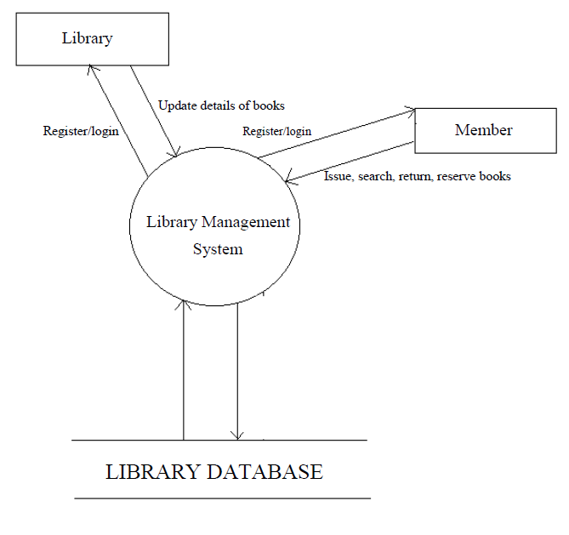

VII – ER Diagram

